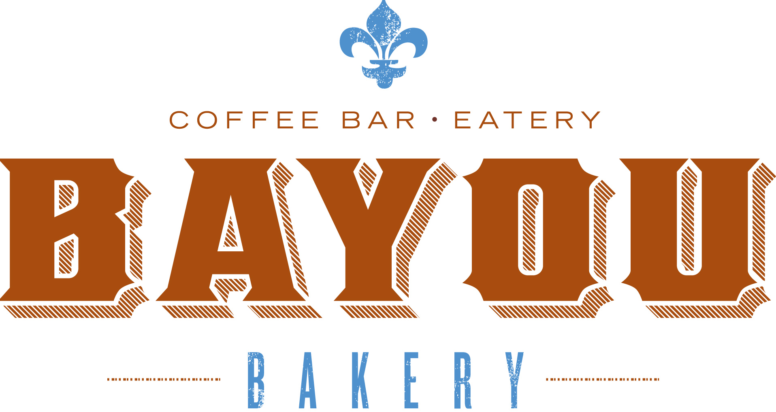

"Way Down Yonder in New Orleans"
New Orleans-born chef David Guas Talks Hometown Favorites on CBS This Morning, Saturday

Tune in to CBS This Morning this coming Saturday, February 9, at 8:30AM EST to hear celebrity chef David Guas, owner of Bayou Bakery Coffee Bar & Eatery in Arlington, Virginia, talk all things N'awlins [always] on The Dish and put on a spread of authentic tastes of his native New Orleans on this national morning special, diving deep into his most-loved NOLA delicacies! Hear all about Guas' most renowned dishes, including his infamous deviled eggs, perfectly golden cornbread, James Baker Pimiento Cheese, and some of his favorites from his cookbook DamGoodSweet - like his luscious Lemon Icebox Pie! Host Michelle Miller was singing his praises all morning with New Orleans in the house, as her husband, Marc Morial, is the former mayor of New Orleans. It was like being back in the Crescent City talking where ya grew up, where ya went to school, and 'where'd ya go get lunch today?' Co-hosts Dana Jacobson and Anthony Mason were not left out of the fun, as they went home with Guas' Trinity of Pralines - Traditional, Chocolate, and Café au Lait. Don't miss out on this mouthwatering segment that will bring a piece of New Orleans right to your TV!

Bayou Bakery, Coffee Bar & Eatery
Courthouse: 1515 N. Courthouse Rd, Arlington, VA - bayoubakeryva.com
For more information:
Simone Rathlé | 703.534.8100
president | simoneink, llc
simone@simonesez.com

